**KIST COLLEGE OF MANAGEMENT**

(Affiliated to Tribhuvan university)



Project Report

on

**"RealEstateNepal"**

**Under Supervision of**

Mr. Prawesh Dhungana

**Submitted By**

Anjan Pudasaini(7210/16)

**Submitted To**

**TRIBHUVAN UNIVERSITY**

Institute of Science and Technology

Kirtipur, Kathmandu, Nepal

November , 2019

**KIST COLLEGE OF MANAGEMENT**

**TRIBHUVAN UNIVERSITY**

**Institute of Science and Technology**



**"RealEstateNepal"**

**A Project Report**

**Submitted To**

**TRIBHUVAN UNIVERSITY**

Institute of Science and Technology

Kirtipur, Kathmandu, Nepal

***In partial fulfillment of the requirements for the Bachelor’s Degree in Information management***

**Submitted By**

Anjan Pudasaini(7210/16)

November , 2019

# LETTER OF APPROVAL

This is to certify that this project prepared by Anjan Pudasaini entitled “Real Estate Nepal” in partial fulfillment of the requirements for the degree of Bachelor in Information Management has been well studied. In our opinion, it is satisfactory in the scope and quality as a project for the required degree.

Mr. Surya Basnet

Coordinator

Department of Bachelor in

Information management

KIST College of Management

Kamalpokhari, Kathmandu

Mr. Prawesh Dhungana

Supervisor

Lecturer

Department of Bachelor in

Information management

KIST College of Management

Kamalpokhari, Kathmandu

External Examiner

# SUPERVISOR’S RECOMMENDATION

I hereby recommend that this project prepared under my supervision by Anjan Pudasaini entitled “Real Estate Nepal” in partial fulfillment of the requirements for the degree of the Bachelor in Information Management be processed for the evaluation.

Mr. Prawesh Dhungana

Supervisor

Lecturer

Department of Bachelor in Information Management

KIST college of Management

Kamalpokhari,Kathmandu

# ACKNOWLEDGEMENT

I am very grateful to the Department of Bachelor in Information Management, KIST College of Management for providing the golden opportunity to work on a major project as a part of Summer project works syllabus. I also express my deep gratitude towards our project supervisor Mr. Prawesh Dhungana for his valuable time, suggestions and feedback during the research and reporting of this project. We are also grateful to our program coordinator Mr. Surya Basnet for his encouragement, feedback, suggestion, and input. I would like to thank our teachers of the BIM Department and my entire classmates for motivation and encouragement.

Anjan Pudasaini (Symbol no:: 7210/16)

# ABSTRACT

This project RealEstateNepal using PHP is developed so that anyone can easily find the perfect house to buy as well as post their house for sale in our website. The person who wants to post house for sale first need to register with the email address. The Email should must be unique. After registration user can easily post their house which is then shown to the home page with proper details.

# TABLE OF CONTENT

LETTER OF APPROVAL iii

SUPERVISOR’S RECOMMENDATION iv

ACKNOWLEDGEMENT v

ABSTRACT vi

TABLE OF CONTENT vii

LIST OF FIGURE ix

LIST OF ABBREVIATION x

CHAPTER 1 1

INTRODUCTION 1

1.1. Background 1

1.2. Problem Statement 1

1.3. Objectives 1

1.4. Scopes and Limitations 2

CHAPTER 2 3

SYSTEM ANALYSIS 3

2.1. Analysis Of Existing System 3

2.2. Requirement collection 4

2.3. Feasibility Study 5

CHAPTER 3 7

SYSTEM DESIGN 7

3.1. Use Case Modeling 7

3.2. Sequence Diagram 8

CHAPTER 4 9

SYSTEM IMPLEMENTATION AND TESTING 9

4.1. User Interface 9

4.2. Tools 12

4.3. Test Case 13

CHAPTER 5 14

MAINTENANCE AND SUPPORT 14

CHAPTER 6 15

CONCLUSION AND ENHANCEMENTS 15

REFERENCE a

# LIST OF FIGURES

Fig 3. 1 Use case Diagram 7

Fig 3. 2 Sequence Diagram 8

Fig 4. 1 Frontend 9

Fig 4. 2 Login and Registration 10

Fig 4. 3 Admin Dashboard 11

Fig 4. 4 Manage Product 11

Fig 4. 5 Add Product **Error! Bookmark not defined.**

# LIST OF ABBREVIATION

**Abbreviation Stands For**

CSS Cascading Style Sheet

HTML Hyper Text Markup Language

PHP PHP: Hypertext Preprocessor

UML Unified Modeling Language

## CHAPTER 1

# INTRODUCTION

### 1.1. Background

The world wide web have spread across most of the household, so naturally, Internet has become by far the best platform for real estate marketing today. Even most of the population are using the internet service, most people in Nepal still rely on various agents for selling as well as buying house for them. They are not seem to make proper utilization of online real estate system which makes the direct contact between buyers and sellers saving customers both time and money.

Today mobile and web based applications have become a part of our day to day life. With the revolution in mobile computing many great features are added to the field and the mobiles are getting smaller, faster and better as the decade passes. Considering this we have developed an efficient and reliable online real estate web application. **RealEstateNepal** simply list the property that the buyers can buy and seller can provide the necessary details and contacts to buyers.

### 1.2. Problem Statement

Although most of the Nepalese population are already familiar with the use of internet and various web applications, we are not being able to use it effectively for certain tasks like property buying and selling instead we rely on various agents. There are still various middleman as a agent in this business who charge high rate of commission for finding properties and most of the people still reply on them for finding the property they need or to sell their property.

### 1.3. Objectives

**RealEstateNepal** is a web application which helps in making a direct contact of property buyers and sellers from the comfort of their home. This website is a online real estate business through which a user can easily post their property as well as find the perfect property for them. The admin user can change the information regarding property selling and cancellation. The system is very useful for individuals for buying and selling purpose of their property as well as it aims to reduce the time and money spent in search of agents and property. Some basic objective of RealEstateNepal are:

1. Make the centralized platform for posting and selling property.
2. Make the easy direct contact between individual buyer and seller.
3. Helps to save individuals time as well as cost spent in search of property.

### 1.4. Scopes and Limitations

Todays world is the world of internet. Use of internet based applications have been rapidly growing in Nepal. So naturally, Internet could become by far the best platform for real estate business in Nepal also. Nowadays when everything is online, how it is possible that real estate left web application behind? There are lots of property buying and selling happening in offline market so the idea is to make a proper online market with centralized collection of various sellers ,buyers and properties making a direct contact between the individual buyers and sellers saving both their time and money.

As we are trying to encourage people the effective use of web application in the real estate business also removing various agents and middleman we might face various obstacle doing that. We might face problem in convincing people about the use of web based application for real estate business and its effectiveness. Also future maintenance should be done in the software to add different new features in the software.

## CHAPTER 2

# SYSTEM ANALYSIS

RealEstateNepal involves the problem-solving technique of making the easy direct contact with the individual property buyers and sellers. There are few web and application portal like (*1ropani.com*) who deals with the posting and buying of individuals property but what makes RealEstateNepal unique is that we provide a easy user interface and fast loading time which encourages them to choose our service.

### 2.1. Analysis Of Existing System

Although there are various real estate websites in Nepal, most of them are not working effectively while only few have a satisfactory performance. 1ropani.com is one of the website which provides an individual seller power to post their property. It also runs quite fast and as well as its features are also satisfactory. It also has a various features that a real estate business should provide to their customers. When the customer visit the site they can also easily list their houses on the website as well as the potential buyer can also see various properties and details associated with particular product.

There are some of the weakness of 1ropani.com which might give us a slight competitive advantage then them. Some of the weakness are

* Website is not responsive
* It has a bad user interface.
* Various information are not properly arranged.
* It still uses unsecure http protocol.

Besides having some weakness 1ropani.com also have a numerous strength. Some of the strength of 1ropani.com are:

* Proper property filtering feature.
* Fast loading of website
* Various varieties of services provided
* Map feature to locate particular property

### 2.2. Requirement collection

There are basically functional and non-functional requirements. Functional requirements are services the system should provide. In this project, the buyer interacts with the application to get information about posted property posted by seller. Seller first logins and the system validates the login credentials. Any user will be able to view the list of posted property and their details. But only the registered sellers will be able to post their property and their profile is maintained. In the other hand, non-functional requirements are the constraints on the services or functions offered by the system. They include timing constraints, constraints on the development process and standards. This project hugely emphasizes on performance of the project. It is reliable, portable, and usable.

#### 2.2.1. Functional Requirement

The sellers can register and login into the system by proving necessary details. After successful registration and login, seller can post property, property details and information regarding sale. Some of the functional requirements of the system are listed below:

* Users Login and Registration
* Users Logout
* Admin panel for editing and deleting the property details
* Search Property By Location
* Profile For Registered Sellers

#### 2.2.2. Non-Functional Requirement

Quality attributes, constraints, goals and non- behavioral requirements of RealEstateNepal system refers to non- functional requirements. These requirements are imposed in the system deals with the issues like usability, extendibility, scalability, Performance and maintainability.

### 2.3. Feasibility Study

#### 2.3.1. Technical Feasibility

Technical feasibility involves determining whether a system can actually be constructed to solve the problem at hand. The following points were considered for the project’s technical feasibility.

* The required technologies (PHP) existed.
* The database management tool (MySQL) was found technically capable to hold data required to install and use the system.

#### 2.3.2. Operational Feasibility

Operational feasibility asks if the system will work when developed and installed. The following points were taken into account for operational feasibility of the proposed system.

* The proposed system causes no harm because it only provides service to the users.
* The system is user friendly so the user can use this system more enthusiastically .
* The system is affordable and has low operational cost because it requires low bandwidth.

#### 2.3.3. Economic Feasibility

The economic feasibility of the project can be shown through the following points.

* The tools and technologies used for the system are free for noncommercial development purposes.
* Since the system is developed as part of project work, there is no manual cost to spend for the proposed system. It can be assured that the project proves economically feasible because all the resources are already available.

#### 

#### 2.3.4. Schedule Feasibility

Typically, Schedule feasibility means estimating how long the system will take to develop, and if it can be completed in a given time period using some methods like payback period. Schedule feasibility is a measure of how reasonable the project timetable is. Since the project was conducted according to the project timetable, it was developed and implemented at the given time.

## CHAPTER 3

# SYSTEM DESIGN

**RealEstateNepal** is a software design that deals with two parties one is individual buyer and another be a individual seller. Buyers and sellers interact with the system and as well as between themselves to sell/buy various properties.

### 3.1. Use Case Modeling

A use case identifies the actors involved in an interaction and names the type of interaction. This is then supplemented by additional information describing the interaction with the system. The additional information may be a textual description or one or more graphical models such as UML sequence or state charts.

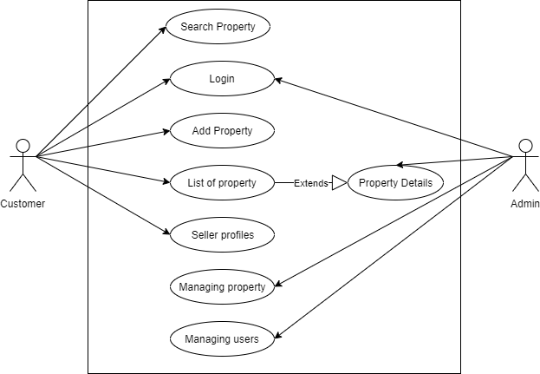

Fig 3. 1 Use case Diagram

### 3.2. Sequence Diagram

UML Sequence diagrams are interaction diagrams that detail how operations are carried out. As sequence diagrams can be used to capture the interaction between objects in the context of a collaboration, one of the primary uses of sequence diagrams is in the transition from requirements expressed as use cases to the next and more formal level of refinement. Use cases are often refined into one or more sequence diagrams.

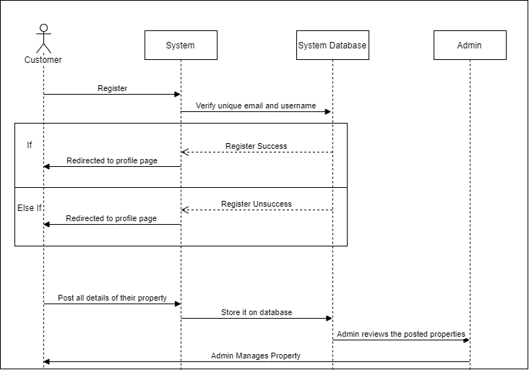

Fig 3. 2 Sequence Diagram

## CHAPTER 4

# SYSTEM IMPLEMENTATION AND TESTING

The system components as identified in the design specification from the design phase and the software requirements specification from the analysis phase are built either from scratch or by composition in the implementation phase. This section documents the issues that arose during the implementation phase together with the adopted solutions. Every task identified in the design specification has been carried out in this phase. So far, no such issues rose that could critically affect the project schedule. All the tasks were completed within the project schedule according to the Gantt chart.

### 4.1. User Interface

#### 4.1.1 Client part

User interface in the client part is designed using CSS, HTML5 and Bootstrap . All other remaining screen shots are listed in appendices.

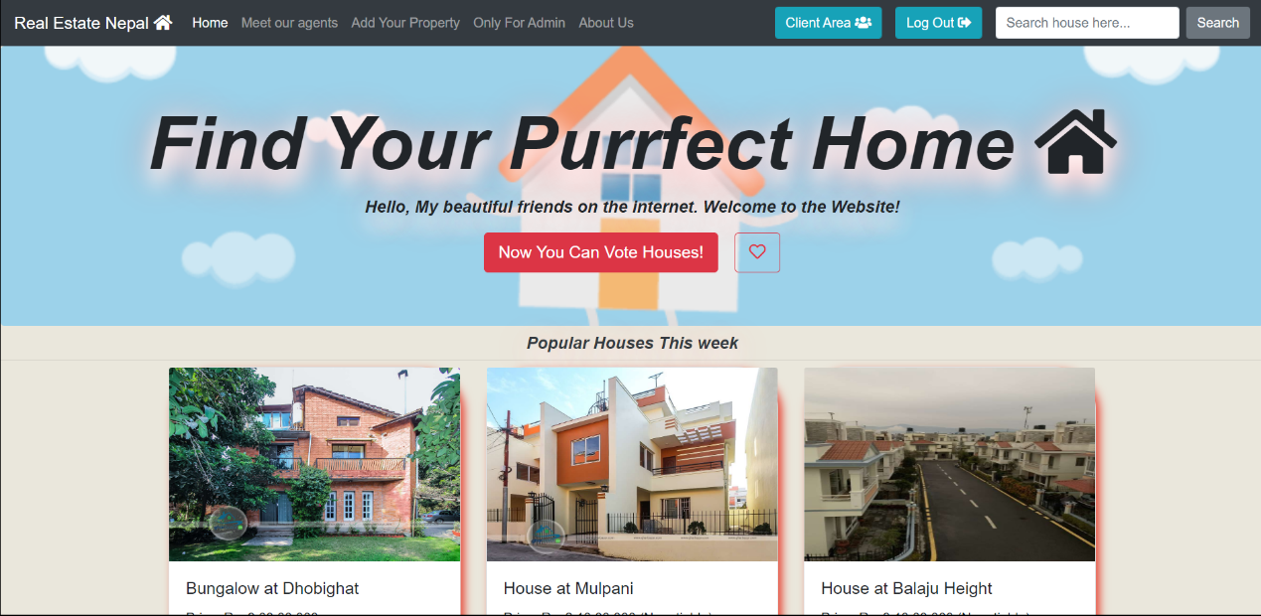

Fig 4. 1 Frontend

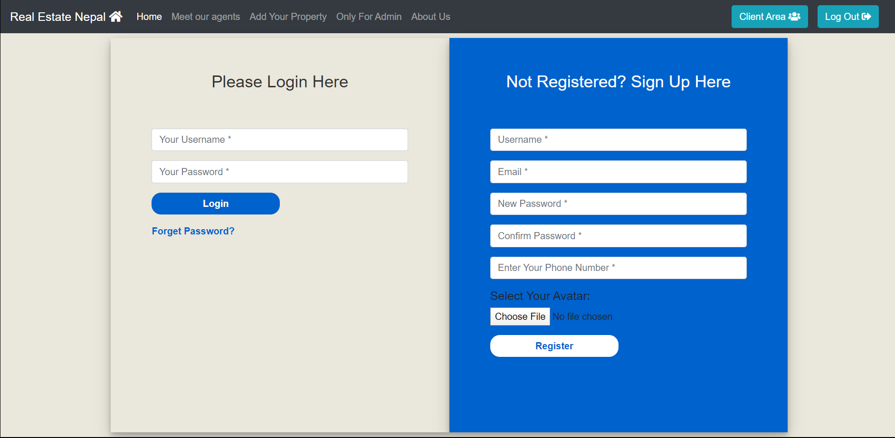

Fig 4. 2 Login and Registration

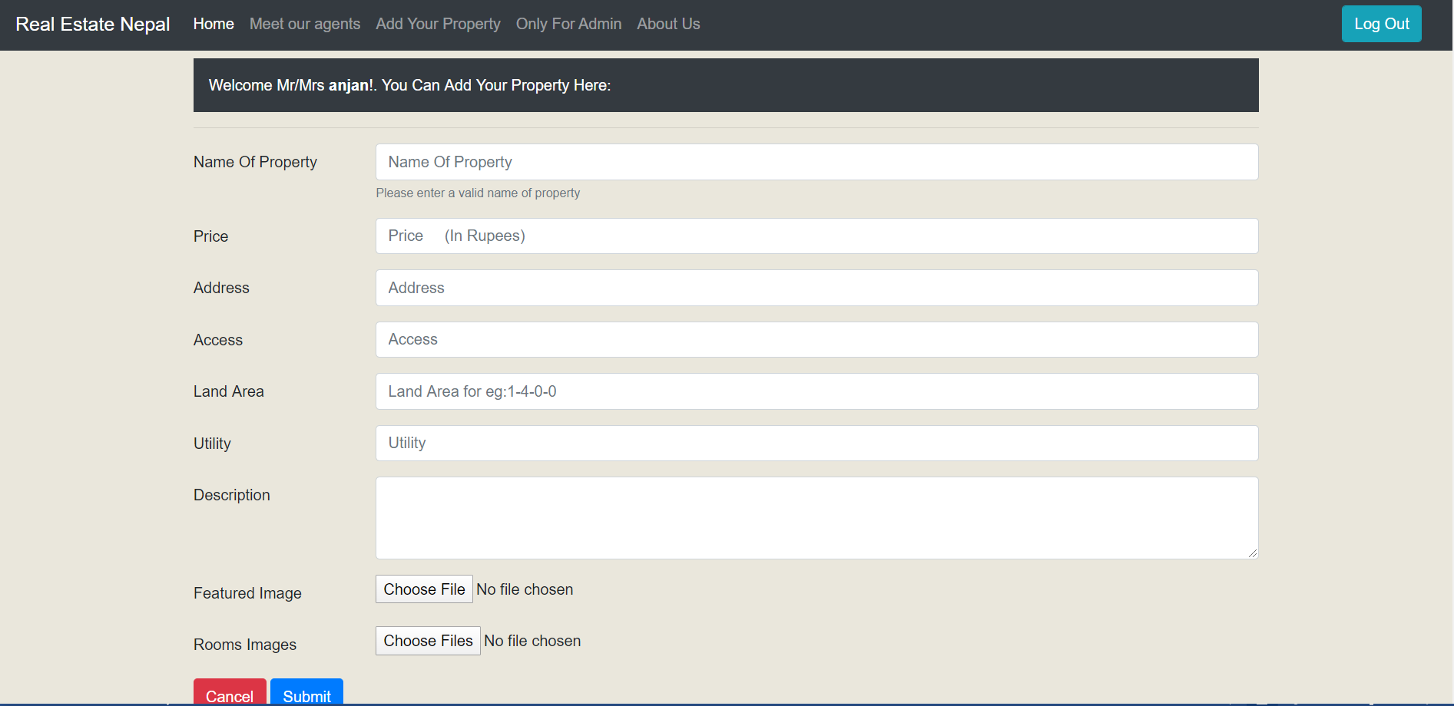

Fig 4. 3 Inserting Property details

#### 4.1.2 Admin Part

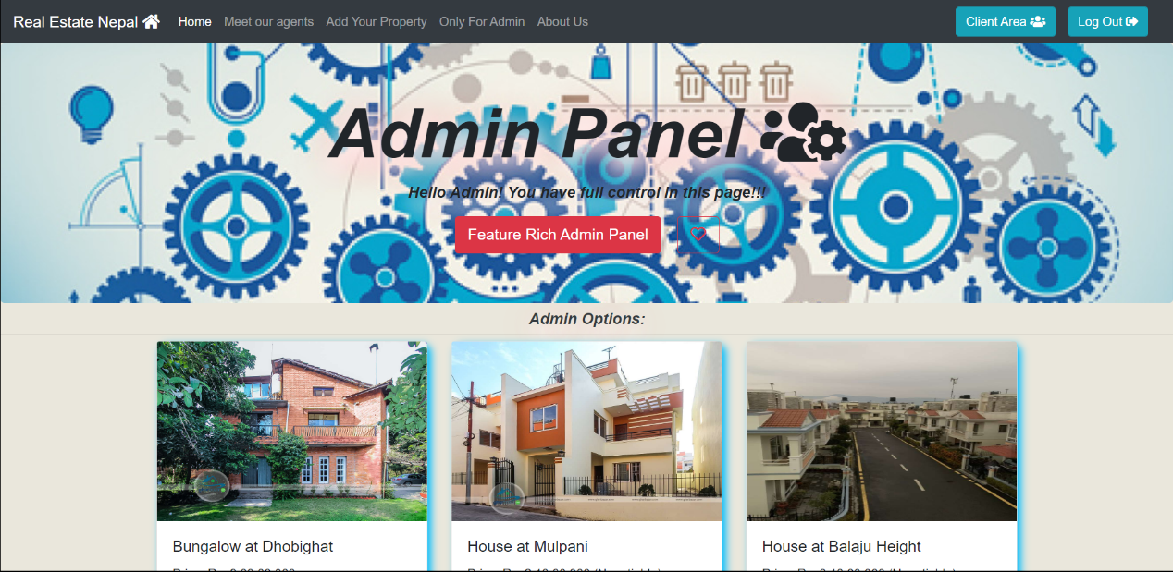

Fig 4. 4 Admin Dashboard

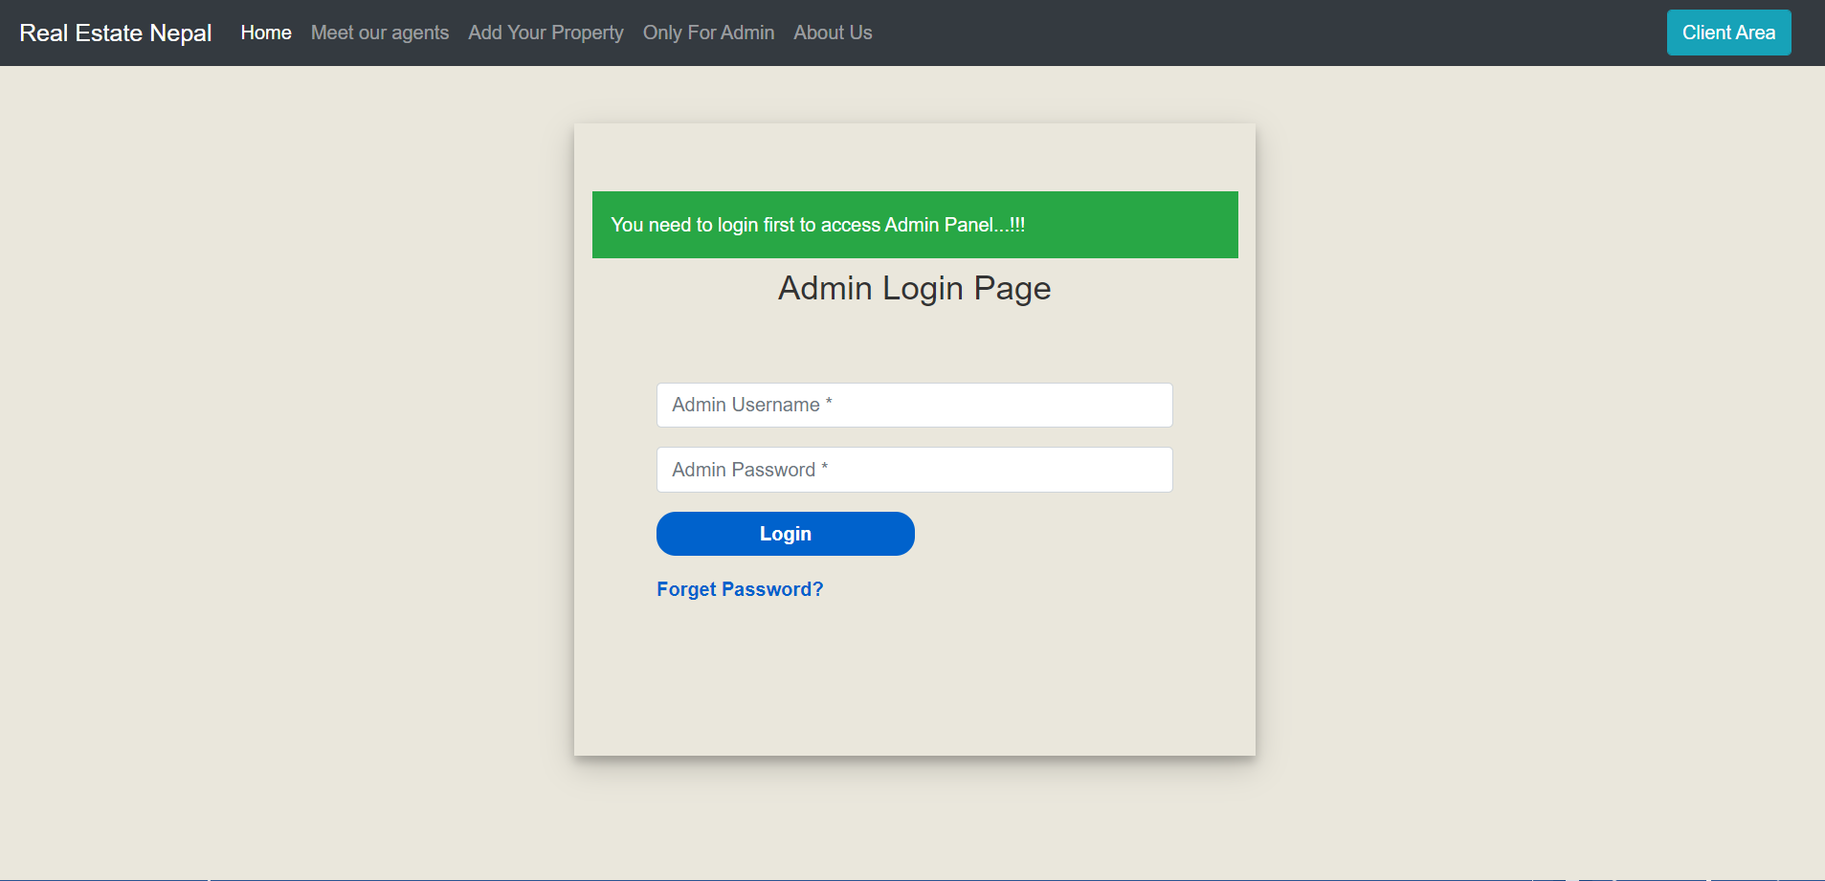

Fig 4. 35Manage Product

### 4.2. Tools

#### 4.2.1. Design Tools

* Draw.io

#### 4.2.2. Implementation Tools

* Visual Studio
* Brackets Text Editor
* Xampp Server
* SQLyog

### 4.3. Test Case

### C:\Users\Dell\Desktop\Summer Project And Viva\Real Estate\test case.jpg

## CHAPTER 5

# MAINTENANCE AND SUPPORT

Due to the various problem that may arise in the Xampp server and PHP, the system should be provided with the maintenance and support in the future.

## CHAPTER 6

# CONCLUSION AND ENHANCEMENTS

The sole purpose of this project is to develop a web based system that helps to make a easy contact and communication between potential property buyers and sellers reducing both time spent and cost of customers. The system helps buyers to find the best property for them as well as sellers to reach the potential buyers easily. Seller will be able to register and their profile is already listed in website so that particular buyer can directly contact particular seller.

Future work will be focused on development of Mobile based system along with future enhancement of Web based system.

# REFERENCE

[1] Software Engineering Ninth Edition Ian Sommerville.